***[Local Vendor Review System](http://1000projects.org/local-vendor-review-system-java-project.html)***

### **Abstract:**

Local Vendor Review System is a web based application developed by using Java and MySQL Technologies, this application is mainly for the customers who are interested in food. Now a day there is no proper way to get the Restaurant Information whether which is providing quality food or not, but this application helps to find good restaurants. This project is developed to improve the quality of the services provided by vendors. There is an option to give feedback of the restaurants so that customers can easily find the restaurants.

### **Existing System:**

In the existing system we don’t have any feature to find the restaurant, we directly go to restaurant and have some food then only we will get to know the food quality and services of the restaurant.

### **Proposed System:**

In this proposed system the customer has an option to give his/her feedback to the particular restaurant so that the user can easily find the better restaurants.

**Use Case Diagram:**

[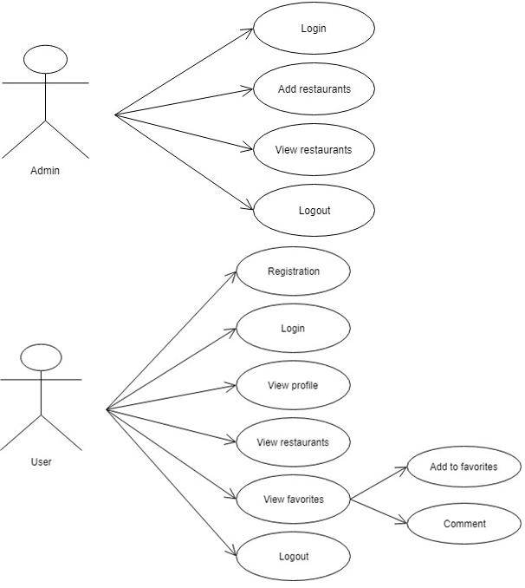](http://1000projects.org/wp-content/uploads/2018/07/Local-Vendor-Review-System-Use-Case-Diagram.png)

**Sequence Diagram:**

[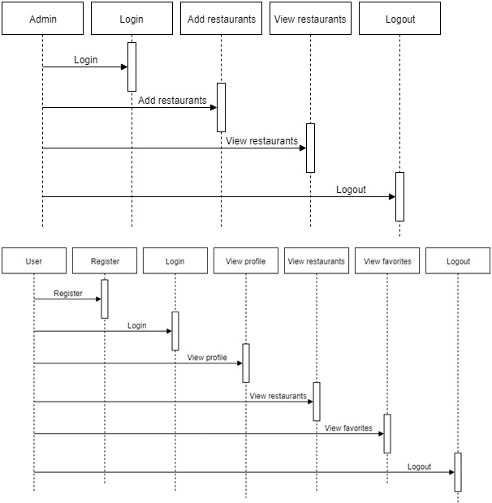](http://1000projects.org/wp-content/uploads/2018/07/Local-Vendor-Review-System-Sequence-Diagram.png)

**Activity Diagram:**

[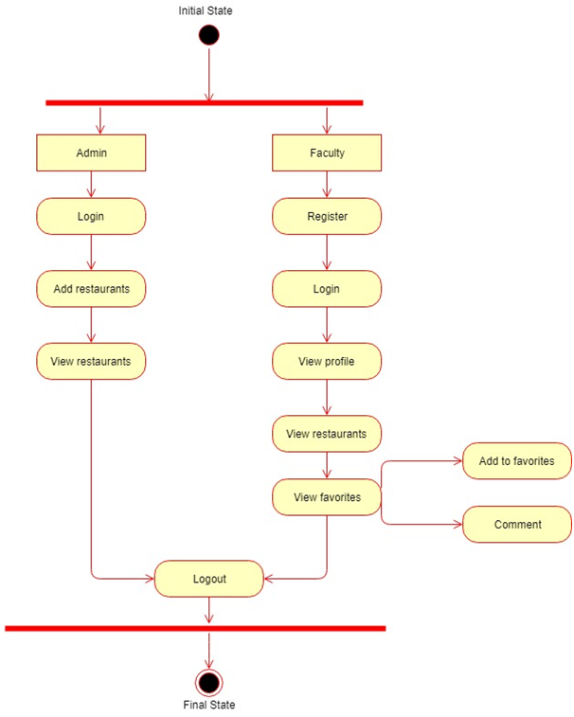](http://1000projects.org/wp-content/uploads/2018/07/Local-Vendor-Review-System-Activity-Diagram.png)

**Class Diagram:**

[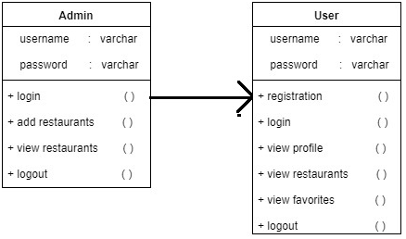](http://1000projects.org/wp-content/uploads/2018/07/Local-Vendor-Review-System-Class-Diagram.png)

**Modules:**

### **Admin:**

Admin needs to get login by entering valid credentials.  Admin can add the area wise restaurants details.  Admin can view all the restaurants.

### **Customer:**

Customer needs to enter all the details in the registration form to get a valid username and password. Customer can see his/her profile information and customer can search restaurants by location or area wise. Customer can find the restaurant details and add restaurants as his/her favourites.

## **Software Requirements:**

**Hardware Requirements:**

Processor-Intel Core, RAM-2 Gb , Hard disk-500 Gb.

**Software Requirements:**

Operating System-Windows 7/8/10, Front End-HTML, CSS, JavaScript NetBeans7.4, JDK 1.7, MySQL 5.5, SQLYog, HTML, JavaScript and CSS.

**All Other Functionalities:**

* Home:
* Foodie:
* Admin Login:
* Admin Home:
* Add Restaurant:
* View Restaurant:
* Registration:
* Customer Login:
* Customer Home:
* Profile:
* View Restaurants:
* View favourites:
* About Us:
* Contact Us:
* Top Reviews:

|  |  |
| --- | --- |
|  |  |